**PROJECT DESIGN PHASE-II**

**TECHNOLOGICAL ARCHITECTURE**

|  |  |
| --- | --- |
| Date | 13 October 2022 |
| Teamid | PTN2022TMID33849 |
| Project Name | Retail Store Stock Inventory Analytics |
| Maximum marks | 4 marks |

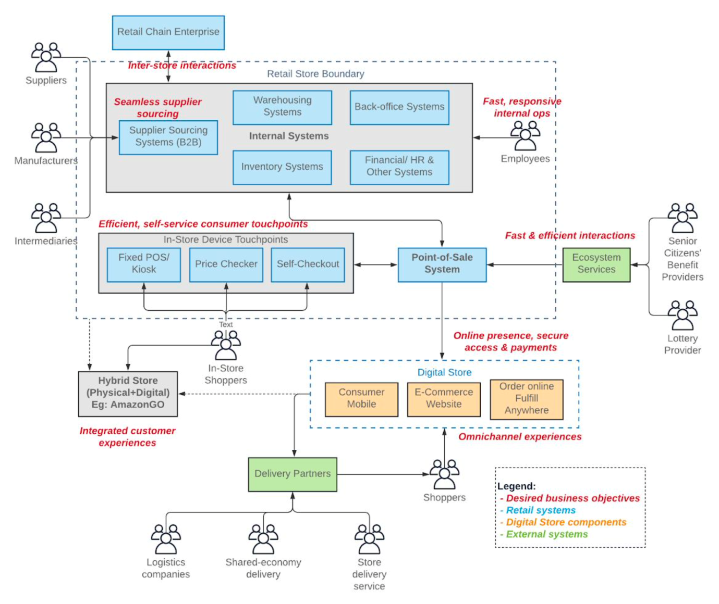

**Table-1 : Components & Technologies:**

|  |  |  |  |
| --- | --- | --- | --- |
| **S.No** | **Component** | **Description** | **Technology** |
|  | User Interface | User Interface (GUI), Command Line Interface (CLI), Natural Language Interface (NLI), Menu-driven Interface and Form-based Interface | Ember JS Backbone JS, Vue JS, Angular JS, React JS, GUI, CLI |
|  | Application Logic-1 | Logical analysis of data (LAD) is a data analysis methodology which combines ideas and concepts from optimization and Boolean functions | Python |
| 3. | Database | Data Type, Configurations etc. | MySQL, NoSQL, etc. |
| 4. | Cloud Database | Database Service on Cloud | IBM DB2, IBM Cloudant etc. |
| 5. | External API-1 | To have more storage and efficient working. | IBM Weather API, etc. |
| 6. | Machine Learning Model | To understand data better | Object Recognition Model, etc. |
| 7. | Infrastructure (Server / Cloud) | Application Deployment on Local System / Cloud  Local Server Configuration:  Cloud Server Configuration : | Local, Cloud Foundry, Kubernetes, etc. |

**Table-2: Application Characteristics:**

| **S.No** | **Characteristics** | **Description** | **Technology** |
| --- | --- | --- | --- |
| 1. | Open-Source Frameworks | Apache kafka, MXnet,Pandas  Matplotlib | Java and scala,python and c++, Python,Matlab. |
|  | Security Implementations | Confidentiality, Integrity and availability  Data masking, data ensure,backupstorage. | Encryption, Tokenization and Authorization |
|  | Scalable Architecture | The measure of a system’s ability to increase or decrease in performance and cost in response to change in application and system processing | Apps, Platforms or Programs That can grow and adapt with ease. |
|  | Availability | If demand rises for certain lines, so should the stock availability for that product. If you fail to provide sufficient stock, especially with more seasonal products, you can and will lose customers. You can turn to category management and forecasting to help understand the rise and decline in demand for your products. | Warehouse maintaining for storing stocks. |
|  | Performance | To measure performance in inventory management, one of the most common metrics to use is the **“**number of inventory turns.” This number is calculated using the ratio of the value of purchased stock to the value of stock on hand. | Radio Frequency Identification (RFID) Technology. |